**HW 7**

**Problem 1**

1. Summary of the model:

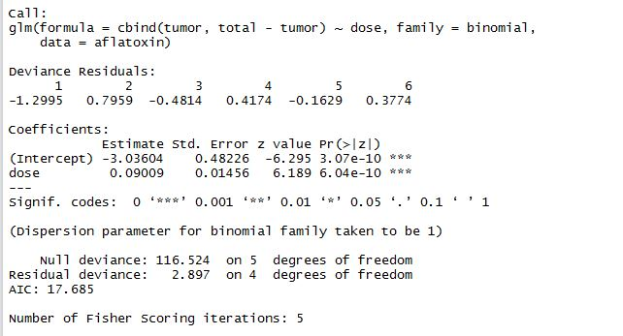

1. Plot:

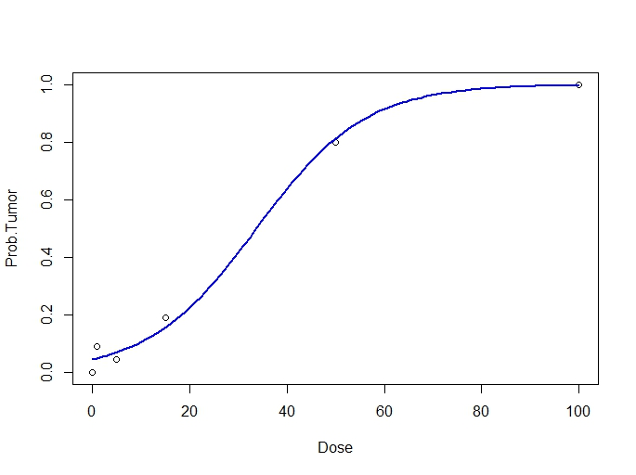

1. Predicted values and the deviance residuals:

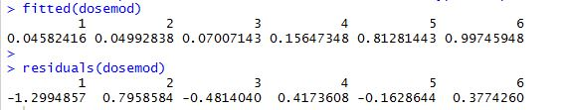

1. Probability and odds at dose = 65

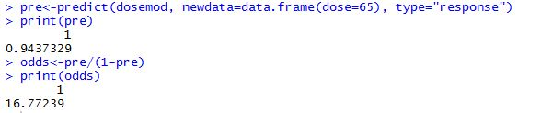

1. The lack-of-fit test: according to the output below, the p-value = 0.58, which is larger than 0.05, and therefore we can conclude that there is no evidence of lack of fit.



1. Model summary and lack-of-fit test: we obtain a p-value as large as 0.377, which is larger than 0.05, and therefore we can conclude that there’s no evidence of lack of fit.

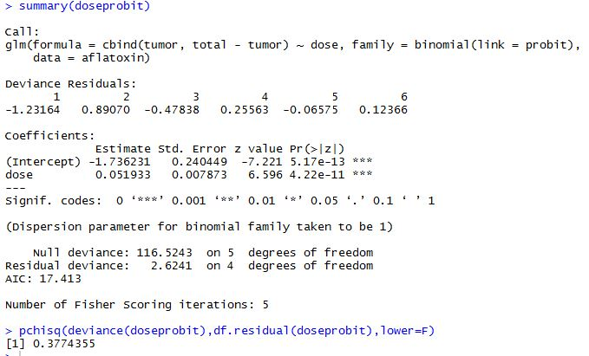

**Problem 2**

1. Model summary:

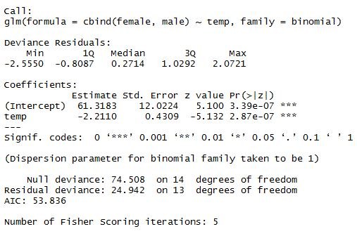

1. Lack-of-fit test: we obtain a p-value as large as 0.98, which is larger than 0.05, and therefore, there’s no evidence of lack of fit.



1. Pearson’s chi-square = 26.24

Lack-of-fit test: p-value = 0.016 < 0.05, indicating lack of fit.

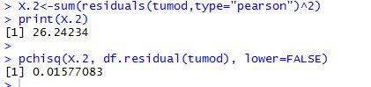

1. Dispersion parameter = 2.02.

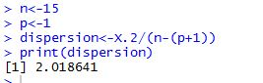

1. New model summary: the estimates did not change, but standard errors have become larger than when dispersion parameter = 1.

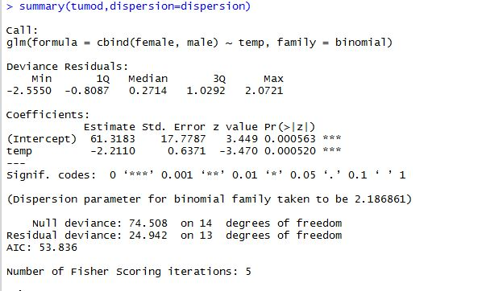

**Problem 3**

1. Variables summary:

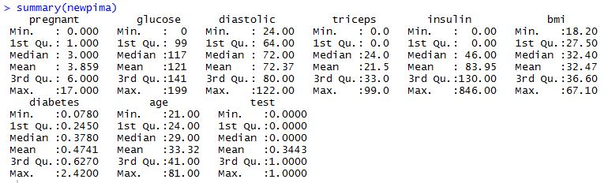

1. Model summary: pregnant, glucose, bmi, and diabetes are the significant variables in the regression model.

A lack-of-fit test is unable to be conducted, because the data are “sparse” ().

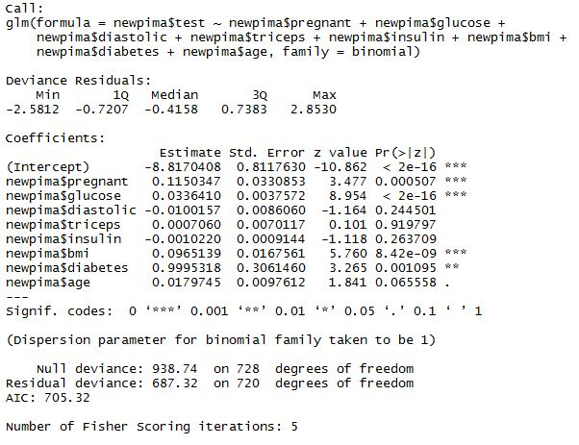

1. Log-odds-ratio: 0.88; CI: [8.80,9.40]

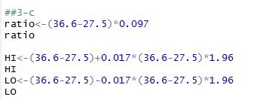

1. Estimated probability = 0.059

95% CI: (0.039, 0.087)

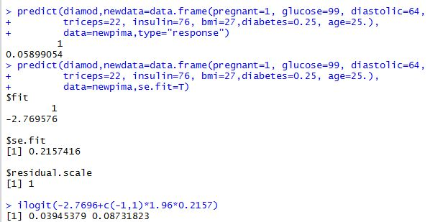

1. Misclassification table:

True positive rate = 142/ (142+109) = 0.566

False positive rate = 54/ (54+424) = 0.113

